i need to install pyspark on my machine and use it in vscode

ChatGPT said:
You can install PySpark locally and run it directly in VS Code without needing a separate Spark cluster. I'll walk you through setting it up, creating a Python project, and running your first Spark program.
The setup depends a little on whether you're using Windows, macOS, or Linux, so I'll start with a standard Python-based setup.

Step 1: Install the prerequisites
You'll need three things:
  - Python — to write and run PySpark code.
  - Java JDK — Spark needs Java to run on your machine.
  - VS Code — your code editor, with the Python extension installed.

1.1 Check whether Python and Java are installed
Open the VS Code terminal using Terminal → New Terminal and run:
bash
python --version
java -version
On Windows, if python doesn't work, try:
powershell
py --version
For a straightforward setup, use Python 3.10 or later and JDK 17. PySpark's current installation documentation supports Python 3.10 and above.

PySpark 4.2.0 documentation
If Python is missing, install it from python.org .
If Java is missing, install a JDK from Eclipse Temurin .

After installing Java, reopen VS Code and check java -version again.

Step 2: Create a PySpark project in VS Code
Open a terminal and run these commands.
bash
mkdir pyspark-project
cd pyspark-project
python -m venv .venv
This creates a project folder and a dedicated Python virtual environment.
Activate the environment using the command for your operating system.

Windows — PowerShell
powershell
.\.venv\Scripts\Activate.ps1

macOS / Linux
bash
source .venv/bin/activate
If PowerShell blocks activation, you can instead run the environment's Python executable directly, or use Command Prompt and run:
bat
.venv\Scripts\activate.bat

Step 3: Install PySpark
With the virtual environment activated, run:
bash
python -m pip install --upgrade pip
python -m pip install pyspark
This installs PySpark into your project environment, rather than globally. The standard pip installation is suitable for local development.
PySpark 4.2.0 documentation
Verify the installation:
bash
python -c "import pyspark; print(pyspark.__version__)"
You should see the installed PySpark version printed in the terminal.

Step 4: Configure VS Code
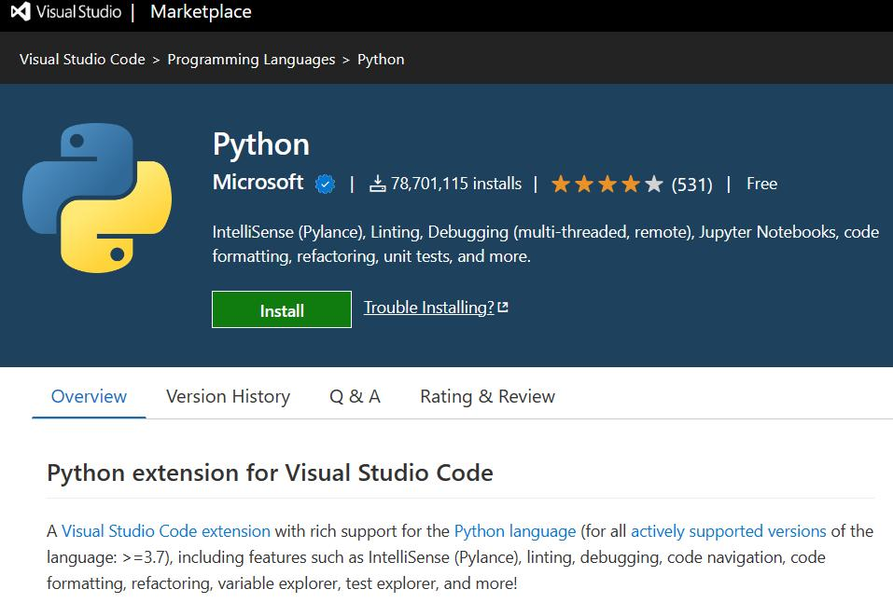
Install the Python extension
In VS Code, open Extensions with Ctrl+Shift+X on Windows/Linux or Cmd+Shift+X on macOS. Search for Python by Microsoft and install it.
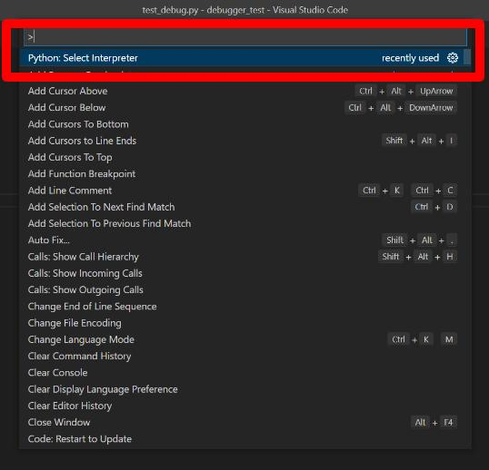
Select your virtual environment
Press Ctrl+Shift+P or Cmd+Shift+P, search for Python: Select Interpreter, and select the interpreter inside your project's .venv folder.
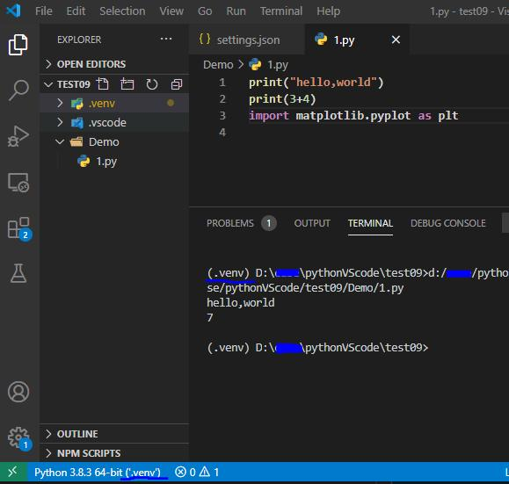
Open your project folder
Select File → Open Folder and open pyspark-project. Create a new file named main.py.
Selecting the correct interpreter ensures VS Code runs code using the environment where PySpark was installed.

Visual Studio Code
+1

Step 5: Run your first PySpark program
Copy this code into main.py:
python

from pyspark.sql import SparkSession

# Create a local Spark session
spark = (
SparkSession.builder
.appName("MyFirstPySparkApp")
.master("local[*]")
.getOrCreate()
)

# Create sample data
data = [
("Alice", 25),
("Bob", 30),
("Charlie", 35),
]

columns = ["name", "age"]

df = spark.createDataFrame(data, columns)

# Display the data
df.show()

# Run a Spark SQL-style operation
df.filter(df.age >= 30).show()

# Stop Spark
spark.stop()
Run it from the VS Code terminal:
bash
python main.py
The first run may take a little while as Spark initializes. You should see output similar to this:
text
+-------+---+
| name|age|
+-------+---+
| Alice| 25|
| Bob| 30|
|Charlie| 35|
+-------+---+
The filtered output should contain Bob and Charlie.
What does local[*] mean? It tells Spark to run locally using the available logical CPU cores. You don't need to set up a separate Spark cluster for this example.

Step 6: Common errors and fixes

Error | What to do
ModuleNotFoundError: No module named 'pyspark' | Select .venv in VS Code and run python -m pip install pyspark again.
JAVA_HOME is not set | Install a JDK and configure JAVA_HOME to its installation directory.
java is not recognized | Add the JDK's bin directory to your system PATH, then reopen VS Code.
Spark starts but exits with a Java error | Check Java compatibility, the selected Python interpreter, and the complete error message.

Official references: PySpark installation guide · VS Code Python environments .

java is installed . how to set JAVA_home

ChatGPT said:
Since Java is already installed on your Windows machine, let's set JAVA_HOME so PySpark can find it.

Step 1: Find your Java installation path
Open VS Code → Terminal → New Terminal and run:
powershell
where.exe java
Example output:
text
C:\Program Files\Eclipse Adoptium\jdk-17.0.12.7-hotspot\bin\java.exe
Your JAVA_HOME should be the JDK folder without \bin\java.exe.
For the example above:
text
C:\Program Files\Eclipse Adoptium\jdk-17.0.12.7-hotspot
If where.exe java shows a path under Common Files\Oracle\Java\javapath, that may be only a Java launcher. Find the actual JDK installation directory instead.

Step 2: Set JAVA_HOME permanently
Open Environment Variables
Press Win + S, search for Edit the system environment variables, and open it.
Open the Environment Variables window
Click Advanced → Environment Variables.
Create JAVA_HOME
Under User variables, click New.
  - Variable name: JAVA_HOME
  - Variable value: your actual JDK folder, for example C:\Program Files\Eclipse Adoptium\jdk-17.0.12.7-hotspot
Click OK.
Add Java to PATH
Under User variables, select Path → Edit → New, then add:
text
%JAVA_HOME%\bin
Click OK on all the windows.

Step 3: Verify the configuration
Close and reopen VS Code so it picks up the new environment variables. In a new PowerShell terminal, run:
powershell
echo $env:JAVA_HOME
java -version
Test-Path "$env:JAVA_HOME\bin\java.exe"
The final command should return:
text
True

Step 4: Test PySpark
Run this in your project terminal:
powershell
python -c "from pyspark.sql import SparkSession; s = SparkSession.builder.master('local[1]').appName('Test').getOrCreate(); print(s.version); s.stop()"
If Spark starts successfully, your Java configuration is working.
If it still fails: Send me the output of where.exe java and echo $env:JAVA_HOME, and I can help you identify the correct path.
- You said:
C:\Users\vasanthk>java -version java version "17.0.12" 2024-07-16 LTS Java(TM) SE Runtime Environment (build 17.0.12+8-LTS-286) Java HotSpot(TM) 64-Bit Server VM (build 17.0.12+8-LTS-286, mixed mode, sharing)
- ChatGPT said:
Great! Java 17 is installed correctly. Now we need to find its installation directory and set JAVA_HOME.

Step 1: Find the Java path
In your Windows Command Prompt, run:
cmd
where java
You may see something like:
text
C:\Program Files\Common Files\Oracle\Java\javapath\java.exe
C:\Program Files\Java\jdk-17\bin\java.exe
The second path, if present, points to the actual JDK installation. Your JAVA_HOME should be its parent directory, excluding \bin\java.exe.

Step 2: Set JAVA_HOME
If your actual JDK directory is C:\Program Files\Java\jdk-17, run this in Command Prompt:
cmd
setx JAVA_HOME "C:\Program Files\Java\jdk-17"
Important: Replace that example path with the actual JDK directory on your machine.
Add Java to your PATH if necessary:
cmd
setx PATH "%PATH%;%JAVA_HOME%\bin"
I recommend adding %JAVA_HOME%\bin through Environment Variables → User variables → Path → New instead, as setx PATH can cause problems with long PATH values.

Step 3: Verify it
Close your existing terminal and open a new Command Prompt:
cmd
echo %JAVA_HOME%
"%JAVA_HOME%\bin\java.exe" -version
You should see your JDK directory and Java version 17.0.12.

Step 4: Test PySpark in VS Code
Restart VS Code, open your project terminal, and run:
cmd
python -c "from pyspark.sql import SparkSession; s = SparkSession.builder.master('local[1]').appName('Test').getOrCreate(); print(s.version); s.stop()"
If you get a Spark version printed without an exception, you're set.
First, run where java and share its output. I'll identify the exact JAVA_HOME path for your installation rather than guessing.

- (.venv) PS C:\Users\vasanthk\MyProject> python -c "from pyspark.sql import SparkSession; s = SparkSession.builder.master('local[1]').appName('Test').getOrCreate(); print(s.version); s.stop()" WARNING: Using incubator modules: jdk.incubator.vector 26/10/23 09:11:54 WARN Shell: Did not find winutils.exe: java.io.FileNotFoundException: java.io.FileNotFoundException: HADOOP_HOME and hadoop.home.dir are unset. -see https://cwiki.apache.org/confluence/display/HADOOP2/WindowsProblems Using Spark's default log4j profile: org/apache/spark/log4j2-defaults.properties Setting default log level to "WARN". To adjust logging level use sc.setLogLevel(newLevel). For SparkR, use setLogLevel(newLevel). 26/10/23 09:11:55 WARN NativeCodeLoader: Unable to load native-hadoop library for your platform... using builtin-java classes where applicable 4.2.0 (.venv) PS C:\Users\vasanthk\MyProject> ERROR: The process with PID 33988 (child process of PID 25524) could not be terminated. Reason: The operation attempted is not supported. ERROR: The process with PID 25524 (child process of PID 16648) could not be terminated. Reason: The operation attempted is not supported. ERROR: The process with PID 16648 (child process of PID 61436) could not be terminated. Reason: The operation attempted is not supported.
- ChatGPT said:
Good news! PySpark is now starting successfully on your Windows machine. 🎉
Your output confirms that Spark version 4.2.0 started and returned its version without a Java gateway error.
There are two warnings and one shutdown issue to understand.

1. What your output means
Spark startup — successful
4.2.0
Java and PySpark are communicating successfully. Your JAVA_HOME configuration is working well enough for Spark to start.
winutils.exe not found
Spark cannot find the optional Windows Hadoop utilities. For basic local learning, this warning often does not prevent Spark from running. Don't download random copies of winutils.exe.
Native Hadoop library not found
Spark is falling back to built-in Java implementations. This is usually fine for local development.
Windows process termination errors
Windows reported that some child processes could not be terminated during shutdown. Since Spark printed its version first, startup succeeded, but we should test whether this happens again.

2. Run a proper PySpark test
Create or update main.py with this code:
python

from pyspark.sql import SparkSession

spark = (
SparkSession.builder
.master("local[2]")
.appName("MyFirstSparkTest")
.getOrCreate()
)

spark.sparkContext.setLogLevel("ERROR")

data = [
("Alice", 25),
("Bob", 30),
("Charlie", 35),
]

df = spark.createDataFrame(data, ["name", "age"])

df.show()

print("Spark version:", spark.version)
print("Master:", spark.sparkContext.master)

spark.stop()
print("Spark stopped successfully.")
Run it in your activated virtual environment:
powershell
python main.py
Expected output includes:
text
+-------+---+
| name|age|
+-------+---+
| Alice| 25|
| Bob| 30|
|Charlie| 35|
+-------+---+

Spark version: 4.2.0
Master: local[2]
Spark stopped successfully.
The process termination messages may or may not recur. If the program completes and returns to the PowerShell prompt, check whether the messages appear again.

3. If the process termination errors persist
First, check your versions:
powershell
python --version
python -m pip show pyspark
java -version
Also check whether Java processes remain after the script exits:
powershell
Get-CimInstance Win32_Process -Filter "Name = 'java.exe'" |
Select-Object ProcessId, CommandLine
Don't terminate all Java processes indiscriminately; other applications may be using them.
One important detail: You're running PySpark 4.2.0, so make sure your installed Java and Python versions meet that release's requirements. If the test prints the table and Spark stopped successfully. but still produces the Windows termination errors, share that output and the version information above so we can narrow down the shutdown issue.

